**Experiment: Common Source Amplifier**

**Aim:**

To implement a common source amplifier of gain 10 and analyze its transient and ac characteristics.

**Tool Used:**

LTspice

**Theory:**

The common-source (CS) amplifier for MOSFET is the analogue of the common emitter amplifier for BJT. Its popularity arises from its high gain, and that by cascading a number of them, larger amplification of the signal can be achieved.

For a Level 3 NMOS let’s assume

VGS = 0.6V

VT = 0.4V

VDD = 1.8V

Kn = 120µA/V2 ,

Which gives a value of (W/L) = 416 for 1mA ID.

Also, for these values gm is attained as 10mΩ-1, therefore for gain 10, RD is taken as 1KΩ.

The value of VDS should be maintained above (VGS - VT = 0.6 - 0.4 = 0.2V) for the transistor to stay in saturation region.

As W/L is 416, the width is taken as 416µm and the length is taken as 1µm.

**Circuit Schematic:**

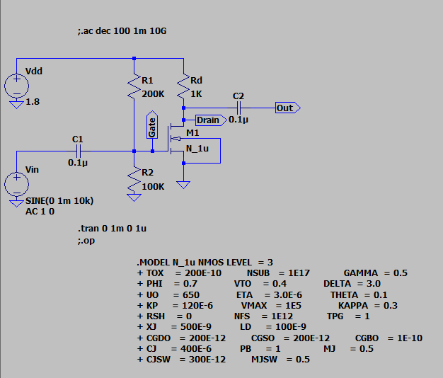

**Output Waveforms:**

DC operating Point

**--- Operating Point ---**

**V(n001): 1.8 voltage**

**V(drain): 0.299922 voltage**

**V(gate): 0.6 voltage**

**V(n002): 0 voltage**

**V(out): 2.99922e-008 voltage**

**Id(M1): 0.00150011 device_current**

**Ig(M1): 0 device_current**

**Ib(M1): -3.09921e-013 device_current**

**Is(M1): -0.00150011 device_current**

**I(C1): 6e-020 device_current**

**I(C2): -2.99922e-020 device_current**

**I(R2): 6e-006 device_current**

**I(R1): 6e-006 device_current**

**I(Rd): 0.00150008 device_current**

**I(Vdd): -0.00150608 device_current**

**I(Vin): 6e-020 device_current**

Transient characteristics

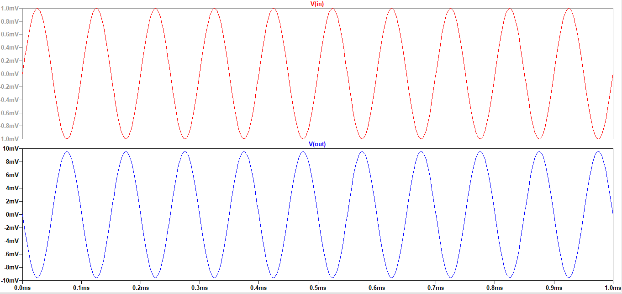

AC Analysis

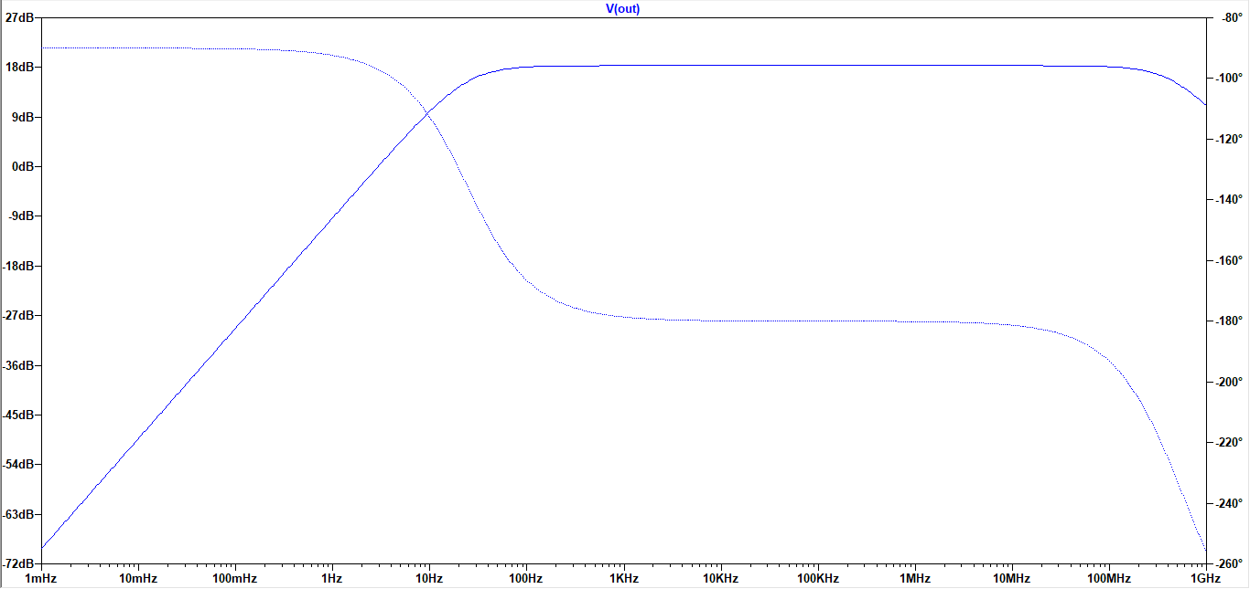

**Result:**

The circuit is designed for a gain of 10 and the output is verified to be correct. The transient and AC characteristics are visualized.